LC#141 LINKED LIST CYCLES
Given head, the head of a linked list, determine if the linked list has a cycle in it.
There is a cycle in a linked list if there is some node in the list that can be reached again by continuously following the next pointer. Internally, pos is used to denote the index of the node that tail's next pointer is connected to. Note that pos is not passed as a parameter.
Return true if there is a cycle in the linked list. Otherwise, return false.

Example 1:
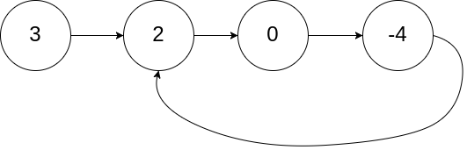
Input: head = [3,2,0,-4], pos = 1
Output: true
Explanation: There is a cycle in the linked list, where the tail connects to the 1st node (0-indexed).

1)Hashmap:
Assign head to a temp variable of type listnode after that push into the map if it not pushed previously . Return true if detected or return false outside the loop.
/**
* class ListNode {
* int val;
* ListNode next;
* ListNode(int x) {
* val = x;
* next = null;
* }
* }*/
public class Solution {
public boolean hasCycle(ListNode head) {
Map <ListNode,Integer> hm = new HashMap();
ListNode temp = head;
while(temp!=null)
{
if(!hm.containsKey(temp))
{
hm.put(temp,1);
temp = temp.next;
}
else
return true; }
return false;
}}

2)using hashset:
Prevents duplicates if dup comes return true finally return false
/**
* class ListNode {
* int val;
* ListNode next;
* ListNode(int x) {
* val = x;
* next = null;
* }
* }
*/
public class Solution {
public boolean hasCycle(ListNode head) {
Set <ListNode> hs = new HashSet();
ListNode temp = head;
while(temp!=null)
{
if(hs.contains(temp))
return true;
hs.add(temp);
temp = temp.next;
}
return false;}}

3)TORTOISE HARE METHOD(OPTIMAL)
/**
* Definition for singly-linked list.
* class ListNode {
* int val;
* ListNode next;
* ListNode(int x) {
* val = x;
* next = null;
* }
* }
*/
public class Solution {
public boolean hasCycle(ListNode head) {
ListNode fast = head , slow = head ;
while(fast!=null && fast.next!=null)
{
fast = fast.next.next;
slow = slow.next;
if(fast==slow)
return true;
}
return false;
}
}

LC#287:FIND THE REPEATING ELEMENT
Given an array of integers nums containing n + 1 integers where each integer is in the range [1, n] inclusive.
There is only one repeated number in nums, return this repeated number.
You must solve the problem without modifying the array nums and using only constant extra space.

Example 1:
Input: nums = [1,3,4,2,2]
Output: 2
Example 2:
Input: nums = [3,1,3,4,2]
Output: 3
Example 3:
Input: nums = [3,3,3,3,3]
Output: 3

->no array modification and op should be inplace

1)so using hashset can solve the problem passes , but not allowed❌
class Solution {
public int findDuplicate(int[] nums) {
Set <Integer> hs = new HashSet();
for(int n: nums)
{
if(hs.contains(n))
return n;
hs.add(n);
}
return 1;
}
}
2)array modification
class Solution {
public int findDuplicate(int[] nums) {
for(int i = 0 ;i < nums.length ;i++)
{
int val = Math.abs(nums[i]);
if(nums[val]<0)
{
return val;
}
nums[val]=-nums[val];
}
return 0; }}

3)OPTIMAL(TORTOISE HARE LINKED LIST)
class Solution {
public int findDuplicate(int[] nums) {
int fast = 0, slow = 0;

// Phase 1: Find intersection point
do {
fast = nums[nums[fast]];
slow = nums[slow];
} while (fast != slow);

// Phase 2: Find cycle entrance (duplicate number)
int slow2 = 0;
while (slow != slow2) {
slow = nums[slow];
slow2 = nums[slow2];
}

return slow;
}
}

LC#202:HAPPY NUMBER
APPROACH 1: hashset
class Solution {
public boolean isHappy(int n) {
Set<Integer> seen = new HashSet<>();
while (n != 1 && !seen.contains(n)) {
seen.add(n);
n = getNext(n);
}
return n == 1;
}

private int getNext(int n) {
int sum = 0;
while (n > 0) {
int d = n % 10;
sum += d * d;
n /= 10;
}
return sum;
}
}

3)TORTOISE HARE DETECTION
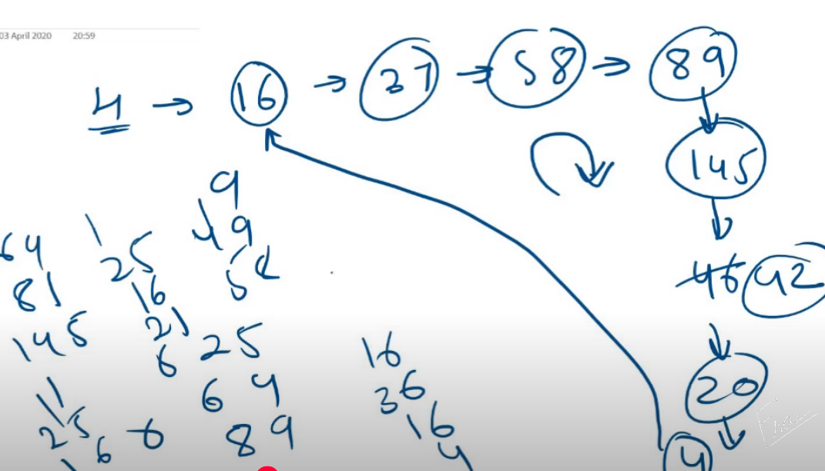
class Solution {
int compute(int n)
{
int res = 0;
while(n>0)
{
int d = n%10;
res = res +(d*d);
n/=10;
}
return res;
}
public boolean isHappy(int n) {
int fast = n , slow = n;
do{
fast = compute(fast);
fast = compute(fast);
slow = compute(slow);
}while(slow!=fast);
return slow==1;
}}

